EXP: 2

1) Alter the table STUDENT2 with following structure.
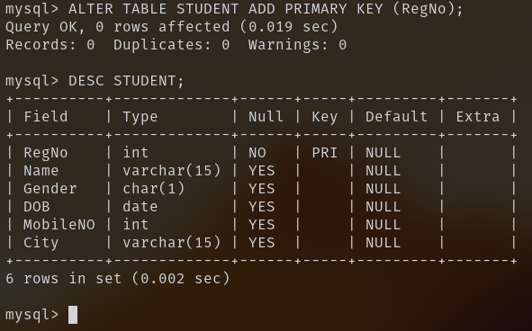
2) Alter the table name FACULTY with following structure.
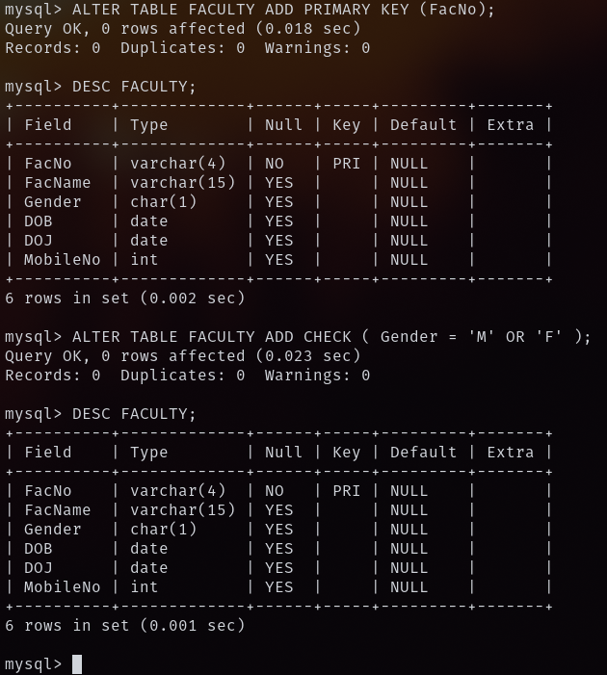
3) Alter the table name DEPARTMENT with following structure.
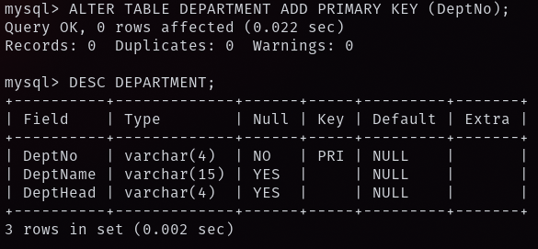
4) Alter the table name COURSE with following structure.
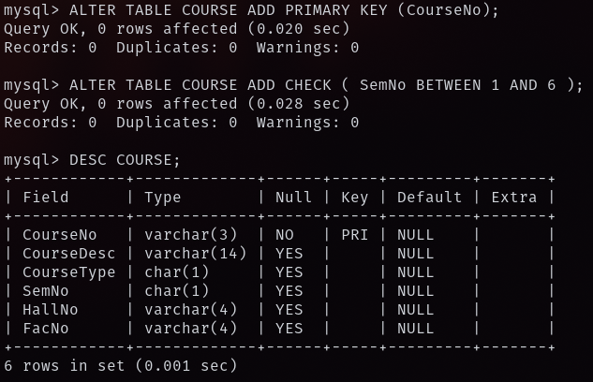

5) Alter the table name STUDENT2 with following structure.
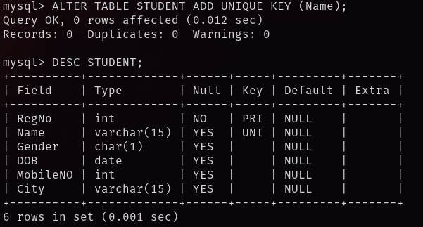
6) After the STUDENT2 & STUDENT3 tables are successfully created, test if you can add a constraint FOREIGN KEY to the RegNo of this table.